Excel Assignment – 7

1. Using Insert Function, give examples of any function available in the

different dropdowns present in the function library. For example

AutoSum, Recently Used, Text, Date & Time, etc.

Ans-

The following are some examples of functions that can be selected from various dropdown menus in the function library:

\*Recently Used: This dropdown displays the functions you have used recently. For example, if you recently used the SUM function, it will appear in this dropdown.

\*AutoSum: This dropdown contains several functions that help you quickly perform calculations on a range of data. For example, you can use the SUM function to add up a range of numbers, or the AVERAGE function to calculate the average of a range of numbers.

\*Text: This dropdown contains functions that allow you to manipulate text. For example, you can use the CONCATENATE function to join two or more strings of text together, or the LEFT function to extract a specified number of characters from the left side of a string.

\*Date & Time: This dropdown contains functions that allow you to work with dates and times. For example, you can use the TODAY function to insert the current date into a cell, or the MONTH function to extract the month from a date.

\*Math & Trig: This dropdown contains functions that allow you to perform various mathematical calculations. For example, you can use the POWER function to raise a number to a power, or the SQRT function to find the square root of a number.

\*Logical: This dropdown contains functions that allow you to evaluate logical expressions. For example, you can use the IF function to perform a conditional test, or the AND function to test if all of a set of conditions are true.

These are just a few examples of the many functions available in the function library. To see the full list of functions, you can click on the "fx" button in the formula bar or go to the "Formulas" tab in the ribbon and click on "Insert Function".

2. What are the different ways you can select columns and rows?

Ans-

\*Click and drag: You can use the mouse to pick a column or row by clicking the column letter or the row number and dragging it across the cells you want to include.

\*Shift + Arrow Keys: To select a range of columns or rows, you can click on the first column or row, hold down the Shift key, and then click on the last column or row. Alternatively, you can click on the first cell in the range and use the arrow keys while holding down the Shift key to extend the selection.

\*Ctrl + Spacebar / Shift + Spacebar: To select an entire column or row, you can click on the column letter or row number to select one cell, and then use the Ctrl + Spacebar (for columns) or Shift + Spacebar (for rows) shortcut to select the entire column or row.

\*Name Box: You can also use the Name Box to select a specific column or row. Simply type the column letter or row number into the Name Box and press Enter to select the entire column or row.

\*Ribbon: You can select columns and rows using the commands in the Ribbon as well. For example, you can go to the "Home" tab and click on the "Format" dropdown to access the "Hide & Unhide" and "Row Height" options.

3. What is AutoFit and why do we use it?

Ans-

AutoFit is a feature in Excel that adjusts the width of a column or the height of a row to fit the contents of the cells within it. It is used to ensure that all the text or data in a cell is visible and not truncated.

AutoFit is important because it makes Excel worksheets easier to read and visually appealing. It reduces the need for manual adjustments and improves workflow efficiency. With AutoFit, we can view all our data without having to scroll horizontally or vertically, making analysis of large amounts of data more efficient.

AutoFit is a simple and quick feature that can save us a lot of time and effort in adjusting column widths or row heights manually. It can be used on one column or row at a time, or on multiple columns or rows simultaneously. It is an essential tool for anyone working with large amounts of data in Excel, as it ensures that all of the data is visible and easy to read, improving our overall productivity and accuracy.

4. How can you insert new rows and columns into the existing table?

Ans-

To insert new rows and columns into an existing table in Excel, follow these steps:

\*Click anywhere in the table to select it.

\*Go to the "Table Tools" tab in the Ribbon.

\*Click on "Design" tab.

\*To insert a row, click on "Insert Rows Below" or "Insert Rows Above" in the "Table Rows" section of the Ribbon.

\*To insert a column, click on "Insert Columns to the Left" or "Insert Columns to the Right" in the "Table Columns" section of the Ribbon.

Alternatively, you can also right-click anywhere within the table to bring up a context menu. From the menu, select "Insert" and then choose "Insert Rows" or "Insert Columns". You can then choose to insert the new rows or columns above or below the selected cell, or to the left or right of the selected cell.

After inserting new rows or columns, the existing table formulae, formatting, and data validation rules will automatically expand to include the new cells. This means you do not need to manually adjust them.

By inserting new rows or columns, you can expand the size of the table and add more data or information as needed.

5. How do you hide and unhide columns in excel?

Ans-

To hide columns in Excel, follow these steps:

\*Select the column you want to hide.

\*Right-click on the selected column.

\*Click on "Hide" from the context menu, or press "Ctrl+0" on your keyboard.

The selected column will be hidden from view. You can also use the "Format" option in the "Home" tab of the Ribbon to hide columns. Click on "Format" and select "Hide & Unhide" from the drop-down menu, then choose "Hide Columns".

To unhide columns in Excel, follow these steps:

\*Select the columns on either side of the hidden column.

\*Right-click on the selected columns.

\*Click on "Unhide" from the context menu, or press "Ctrl+Shift+0" on your keyboard.

The hidden column will now be visible again. Alternatively, you can use the "Format" option in the "Home" tab of the Ribbon to unhide columns. Click on "Format" and select "Hide & Unhide" from the drop-down menu, then choose "Unhide Columns".

6. Create an appropriate table within the worksheet and use different

functions available in the AutoSum command.

Ans-

Count function

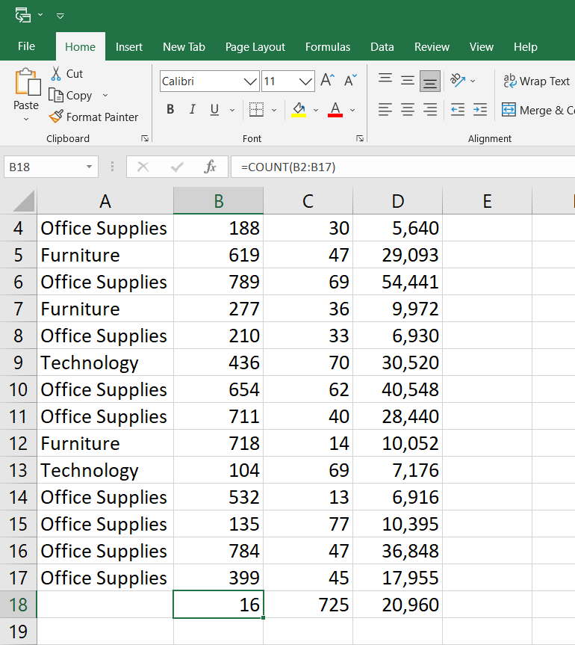

Sum function

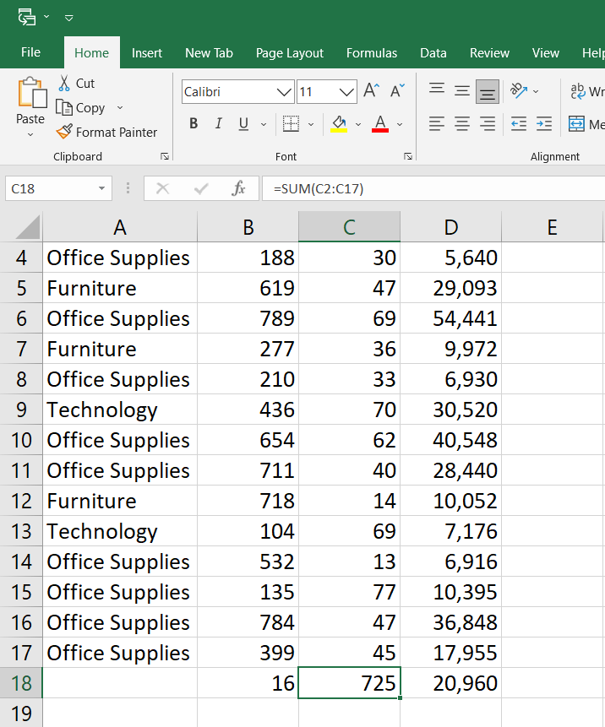

Average function

